LAB # 04

**RMI CALLBACK:**

**Task: Develop the RMI Callback application of Payroll and PayrollMessage services for calculating the earnings.**

**Interface:**

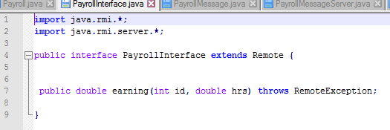

**MessageInterface:**

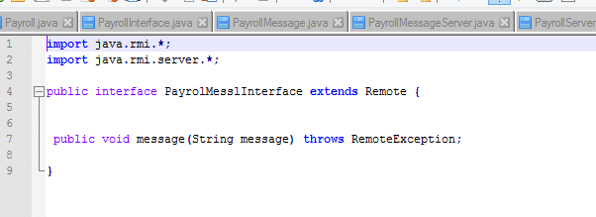

**Payroll:**

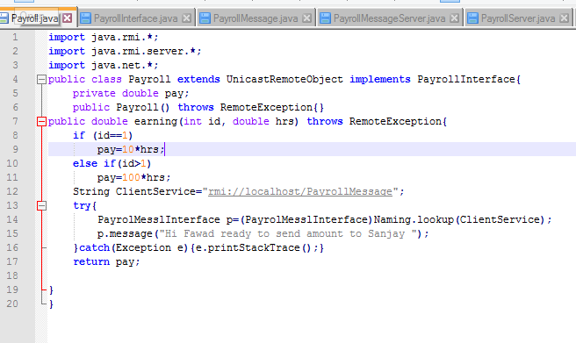

**PayrollServer**

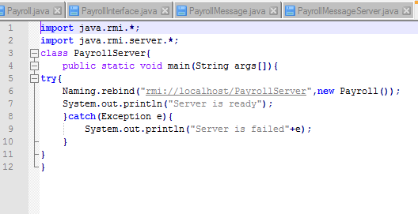

**PayrollMessage:**

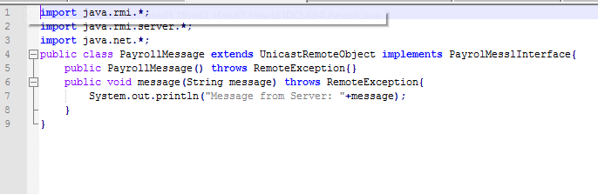

**PayrollMessageServer:**

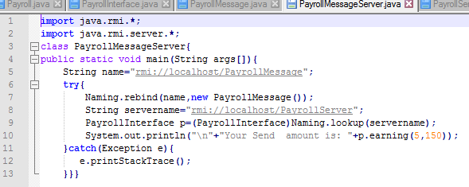

**OUTPUT:**

